Physical Development
Physical activity is vital in children’s all-round development, enabling them to pursue happy, healthy and active lives7. Gross and fine motor experiences develop incrementally throughout early childhood, starting with sensory explorations and the development of a child’s strength, co-ordination and positional awareness through tummy time, crawling and play movement with both objects and adults. By creating games and providing opportunities for play both indoors and outdoors, adults can support children to develop their core strength, stability, balance, spatial awareness, co-ordination and agility. Gross motor skills provide the foundation for developing healthy bodies and social and emotional well-being. Fine motor control and precision helps with hand-eye co-ordination, which is later linked to early literacy. Repeated and varied opportunities to explore and play with small world activities, puzzles, arts and crafts and the practice of using small tools, with feedback and support from adults, allow children to develop proficiency, control and confidence.
Gross Motor Skills- ELG
- Negotiate space and obstacles safely, with consideration for themselves and others

 | 18 months- 3 years | 3 & 4 year olds | Reception | ELG | Provisions | Links to KS1 NC
Physical Development | Start to use stairs independently  Build independently with a variety of resources  Independently use ropes and swings | Go up stairs and steps or climb using alternate feet  Collaborate with others  to manage large items etc. | Confidently use a range of small and large equipment and obstacles | Negotiate space and obstacles | Provide obstacle course equipment outside  Provide large scale building/ PE equipment to make courses and use/ move etc.  PE lessons in Summer term | PE- Master basic movements including agility and co-ordination,
Physical Development |  | Discussion over safety with children | Discuss need for rules and how to remain safe | Show understanding of safety precautions

- Demonstrate strength, balance and co-ordination
 | 18 months – 3 years | 3 & 4 year olds | Reception | ELG | Provisions | Links to KS1 NC
Physical Development | Fit into spaces e.g. dens  and large boxes | Match tasks to activities | Core muscles for good posture  Overall body skills Movement fluency | Strength Balance  Co-ordination | Ribbon twirling  Large scale mark making Outdoor skills- climbing, running, obstacle courses with challenges.  Balance boards, Marble maze  Stilts  Wheelbarrows, carts, balance bike training. | PE-Master basic movements including developing balance, agility and co-ordination,
Physical Development | Gradually gain control of their own body through practice of large scale movements | Use large movements  e.g. streamers etc (shoulder pivot)

- Move energetically, such as running, jumping, dancing, hopping, skipping and climbing
 | 18 months- 3 years | 3 & 4 year olds | Reception | ELG | Provisions | Links to KS1 NC
Physical Development | Sit on and push along a wheeled toy  Use a scooter or ride a  tricycle | Develop movement including use of bikes, scooters etc. | Revise and use fundamental movement skills: roll, crawl, walk, jump, run, hop, skip, climb | Different movement styles- hopping, skipping, jumping, climbing, dancing, running | Large construction  Slides and tunnels for rolling, crawling etc.  Outdoor group games, parachute  Variety of balls and items to throw and kick, scoops, bats and hockey sticks.  Variety of ride ons, wheelbarrows, crate car.  Scarves and ribbons for dance | PE - master basic movements including running, jumping, throwing and catching.
Physical Development | Walk, run, jump and climb  Spin and roll | Skip, hop, stand on one leg- games
Physical Development | Start to kick, throw and catch balls | Ball skills | Ball skills: throwing, catching, kicking,  passing, patting etc.

Fine Motor Skills- ELG
- Hold a pencil effectively in preparation for writing (nearly always tripod grip)

 | 18 months – 3 years | 3 & 4 year olds | Reception | ELG | Provisions | Links to KS1 NC
Physical Development | Explore different materials and tools  Develop manipulation and control | Use a comfortable grip  with good control | Develop a comfortable grip which shows good pencil and pen control | Hold pencil effectively- tripod grip | Table and chairs at appropriate heights  Correct pencils and grips to support grip- consider left handers  Adult intervention where necessary | English- sit correctly at a table, holding a pencil comfortably and correctly
Physical Development |  | Show a preference for a  dominant hand
Physical Development |  |  | Use core muscle strength to achieve good posture | Sit comfortably at a table to write- good  posture
Physical Development |  |  | Develop the foundations of an appropriate handwriting style | Form letters accurately using the correct movements (shoulder  pivot etc)

PENCIL GRIP PROGRESSION CHART
Grip type | Pincer Grip | Palmer Sulphinate  Grip (Fist) | Digital Pronate Grip | Static Tripod Grip | Dynamic Tripod Grip
Typical Age | 10- 12 months | 15-18 months | 2- 3years | 3- 5years | 4- 6years
Description | Using the pads of the index finger and thumb to begin picking up smaller objects (not usually pencils but the start of grip strength) | Pencil is held by the full fist and makes light marks.  Movement is from the shoulder pivot and uses the whole arm | Pencil is held by all the fingers but the palm faces down towards the page  Movement comes from the wrist and uses wrist,  hand and fingers | Pencil is held by three fingers and the movement comes from the wrist More intricate mark making can take place  Several variations based on  finger positioning | Pencil is stable in the traditional grip  The thumb and fingers leave an open space Pencil moves efficiently  and therefore mark making  is more intricate
Visual | 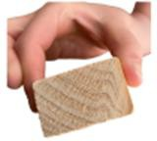 | 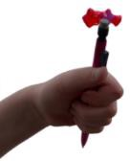 | 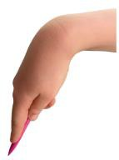 | 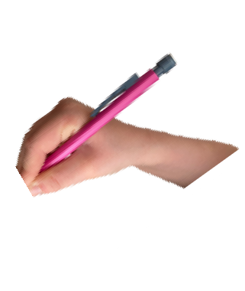 | 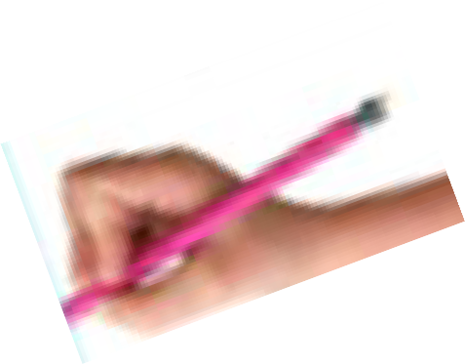
Development Opportunities | Providing small objects to pick up  Encouraging construction  e.g. building blocks Playdough and threading | Large scale mark making  e.g. chalk on floor, easel work, etc.  Circles and lines to copy  Playdough | Smaller scale mark making  Zig Zag lines to copy and trace  Playdough | Smaller mark making Name writing Starting with letter  formations (Reception)  Playdough | Smaller mark making Letter formation Writing  Pencil Grips  Playdough

- Use a range of small tools e.g. scissors paint brushes, cutlery

 | 18 months- 3 years | 3 & 4 year olds | Reception | ELG | Provisions | Links to KS1 NC
Physical Development | Explore different  materials and tools | Use one handed tools  and equipment | Develop small motor skills to use a range of tools competently | Using small tools | Appropriate tools and equipment- different sized paintbrushes, scissors, sticks, stampers, spreaders, cutlery in the dining hall, hammers, saws.  Dough disco  Play doh, Art area, Creative corner, DT bench, Role play | DT- select from and use a range of tools and equipment to perform practical tasks.
Physical Development | Use large and small motor skills to do things independently e.g. buttons | Start to eat independently with a knife and fork

SCISSOR USE PROGRESSION CHART
Scissor Use | Holds scissors in both hands and explores open and shutting | Opens and closes blades with scissors in one hand (not using paper) | Makes snips in paper | Uses a helping hand (non dominant) to guide the paper | Cuts- Straight line Curved line Circles Square Shape  More complex shapes
Vocabulary | Open, shut, safe, scissor,  cut, snip | Open, shut, close, scissor,  cut, snip, thumb, fingers | Across, forward, side to  side | Move, change, help, slide,  hold still, | Cut, snip, curve, open,  shut, follow, forwards, turn
Development Opportunities | Free exploration  Finger strength activities  e.g. playdough and other malleable materials | Encourage the thumb up position  Practise using on shaving foam, playdough | Provide scissors and paper in the creative areas for exploration | Model using the alternative hand to move the paper  Strengthen co-ordination and use of both hands through threading and  lacing activities | Shapes to cut out Scissor exploration

- Begin to show accuracy and care when drawing
 | 18 months- 3years | 3 & 4 year olds | Reception | ELG | Provisions | Links to KS1 NC
Physical Development | Explore different materials and tools  Develop manipulation and control | Draw with increasing complexity and detail (EAD) | Draw with increasing complexity and detail- develop good techniques | Accuracy and care when drawing | Drawing table  Art area  Observational drawing opportunities | Art-to use drawing, painting and sculpture to develop and share their ideas, experiences and imagination

