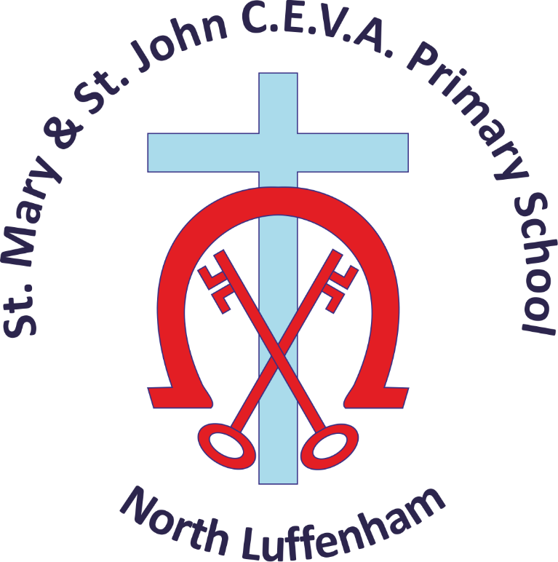

Admissions Policy
Academic Year 2027- 2028

This policy is reviewed annually by the governing body, and was last reviewed on:-

18/01/17 – Approved by Full Governing Body (VERSION: November 2016)
25/08/17 – Policy Updated to ‘Version July 2017’, to be approved by Full Govering Body Sept 2017
Let your light shine _{Matthew 5:16}

This policy is reviewed annually by the governing body, and was last reviewed on:-

18/01/17 – Approved by Full Governing Body (VERSION: November 2016)
25/08/17 – Policy Updated to ‘Version July 2017’, to be approved by Full Govering Body Sept 2017
This policy is reviewed annually by the governing body, and was last reviewed on:-

18/01/17 – Approved by Full Governing Body (VERSION: November 2016)
25/08/17 – Policy Updated to ‘Version July 2017’, to be approved by Full Govering Body Sept 2017

This policy is reviewed annually by the governing body, and was last reviewed on:-

18/01/17 – Approved by Full Governing Body (VERSION: November 2016)
25/08/17 – Policy Updated to ‘Version July 2017’, to be approved by Full Govering Body Sept 2017
This policy is reviewed annually by the governing body, and was last reviewed on:-

18/01/17 – Approved by Full Governing Body (VERSION: November 2016)
25/08/17 – Policy Updated to ‘Version July 2017’, to be approved by Full Govering Body Sept 2017
- INTRODUCTION

St Mary & St John is a Church of England Voluntary Aided (C.E.V.A.) Primary School within the Diocese of Peterborough. As a church school we welcome all pupils as God’s children, whether they have a faith, or no faith. Through nurture and first-class teaching, it is our vision for every unique individual within our school community to grow in mind, body and soul in the grace and knowledge of our Lord and Saviour Jesus Christ, and to flourish, encouraging ‘the fruit of the spirit’ to shine in all that they do.

The Governing Body (GB) is the Admission Authority for this Voluntary Aided School and is therefore responsible for the admission of children to the School.

The Governing Body, through this policy, comply with ‘The School Admissions Code of Practice’. (https://www.gov.uk/government/publications/school-admissions-code--2) The Code states that, in drawing up their admissions arrangements, Admissions Authorities must ensure that the practices and the criteria used to decide the allocation of school places are fair, clear and objective. Parents should be able to look at a set of arrangements and understand easily how places for that school will be allocated.

Children of UK Service Personnel are welcomed. The Governing Body, through this policy, will pay due regard to the Armed Forces Covenant.

The Department for Education (DfE) Admissions Code requires that admissions for children starting school for the first time in the Early Years Foundation Stage – Reception year group, be co-ordinated by the Local Authority for all schools regardless of who the Admissions Authority is. This is in order to provide a better service for parents and carers. The co-ordination provides a common application form and a common timetable.

The Governing Body will abide by application and notification dates used by Rutland County Council.

- HOW PARENTS CAN APPLY FOR THEIR CHILD TO BE ADMITTED TO ST MARY & ST JOHN

In the first instance, we warmly invite you to come and visit the school, meet the Headteacher, staff and children and see the school in action before making the important decision on behalf of your child.

There are two different categories of admission, each of which is considered and processed in a different way, as outlined below.

The Governors will admit up to their PAN (Published Admission Number) which is the number of pupils the school can accommodate in each year group. St Mary & St John’s PAN is 28. If the number of children applying for entry exceeds the places available, the Governors will use the oversubscription criteria set out below in order to determine whether a child is accepted or not.

The Governors, in accordance with the Admissions Code of Practice, in allocating places will give priority to:

- all pupils with an Education, Health and Care Plan, where St Mary and St John C.E.V.A. Primary School is specifically named on the Plan.

- children of UK Service Personnel being relocated to the area in advance of their arrival, providing their application is accompanied by an official letter stating a relocation date. Where the school is oversubscribed, the Admissions Authority will allocate places in accordance with their oversubscription criteria below and as such will require some level of certainty about the family’s new intended address, so that they can make sure they allocate a place lawfully.

The places available will thus be the PAN less the number admitted under these priorities.

- ADMISSION INTO THE EARLY YEARS FOUNDATION STAGE (RECEPTION CLASS) – AT THE START OF THE ACADEMIC YEAR:

The Department for Education (DfE) Admissions Code 2014 requires that admissions for children starting school for the first time in the Early Years Foundation Stage – Reception year group, be co-ordinated by the Local Authority for all schools regardless of who the Admissions Authority is. This is in order to provide a better service for parents and carers. The co-ordination provides a common application form and a common timetable.

In Rutland, children enter school at the start of the academic year in which they become five. There is one admission date per year, in late August, early September (i.e. The start of the school year). Therefore, parents who would like their child to be admitted to St Mary & St John during the year their child is five should ensure that they complete and submit the necessary application form by the primary school applications national closing date. The Local Authority will then notify parents of the school place offered to their child on the national offer day for primary school places.

The Local Authority publishes information about starting school on their website www.rutland.gov.uk/admissions and produces a brochure entitled ‘Starting Primary School’ that can be downloaded. This explains the admissions process for parents and gives all the necessary information, including the timetable and how parents can apply for a place in the school of their choice.

Parents have the right to express a preference for the school of their choice and they should do so on the application form. Expressing a preference does not, in itself, guarantee a place at this school.

Parents with children who attend ‘Little Saints’ pre-school, although attached to St Mary & St John C.E.V.A. Primary School, must still apply for a place in the Early Years Foundation Stage – Reception Class, as stated above. The Governing Body is not permitted to offer a direct route into the main school on the basis of attending ‘Little Saints’, as this prejudices parents who do not wish to send their children to pre-school or nursery before the statutory school age.

Those parents thinking of deferring entry for their child until they are five years of age will need to inform their Local Authority and complete the application process the following year. A place will not be held by the school for your child and there is no guarantee of a place being available the following year.

- IN-YEAR ADMISSIONS TO ALL YEAR GROUPS

The Governing Body, as the Admissions Authority for St Mary & St John C.E.V.A. Primary School is responsible for all admissions outside the normal admissions rounds. These admissions are known as ‘in- year’ admissions and refer to a child who is not starting primary school for the first time (normal admissions rounds) but who is changing from one primary school to another. All applications must be submitted directly to the school. If it is a planned, delayed move, which can be especially applicable to military families, applications should be received in the term (Autumn, Spring, Summer) before the child is looking to start. We will then send a response in writing to advise whether we are able to offer a school place.

- OVERSUBSCRIPTION CRITERIA:
If the situation arises where there are more applications than there are places available in either category of admission, the Governors will admit pupils according to the following criteria, which are listed in order of priority.

- ‘looked after children’ and all previously looked after children, including those children who appear (to the admission authority) to have been in state care outside of England and ceased to be in state care as a result of being adopted.

- Siblings¹ of children attending the school at the time of admission.

- children of staff at the school (i.e. people employed on a permanent contract in any capacity):
- Where a member of staff has been employed at the school for two or more years at the time at which the application for admission to the school is made, and/or
- The member of staff is recruited to fill a vacant post for which there is a demonstrable skill shortage.

- children resident² with their parent(s)/legal guardian(s) in the villages of North and South Luffenham, Morcott, Lyndon, Barrowden and Wakerley whose parent(s)/legal guardian(s) is/are part of the worshipping community³ at any church which is a member of Churches Together in England, this includes the Church of England.

In addition to completing the Rutland County Council application form, applications under this criterion must be made on form SIF A⁴ and returned to the school by the deadline for applications.

- to children resident² with their parent(s)/legal guardian(s) in the villages of North and South Luffenham, Morcott, Lyndon, Barrowden and Wakerley.

- to children who are on roll in ‘Little Saints’, our pre-school, at the time of application for admission.

- to children with parent(s)/legal guardian(s) who is/are ‘part of the worshipping community³’ of any Church which is a member of Churches Together in England, this includes the Church of England, who are not resident in the villages identified in c) above.

In addition to completing the Rutland County Council application form, applications under this criterion must be made on form SIF A⁴ and returned to the school by the deadline for applications.

- to children of parent(s)/legal guardian(s) who do not live in the villages of North and South Luffenham, Morcott, Lyndon, Barrowden and Wakerley.

- TIE BREAKING
Where there are more applications than places available in any one category, applications will be prioritised on the distance from the child’s home to the main entrance of the school. Distance from home to school will be measured as a straight line on a digital map from the front door of the child’s main residence to the main entrance of the school.

- LATE ADMISSIONS
The Governing Body will deal with late applications (those received after the national closing date) after all the “on time” applications have been processed.

- ADMISSION APPEALS
The Governing Body will admit up to the published admission number, as defined in 2) above. If a child is not offered a place at the school, it is because to do so would prejudice the education of other children by allowing the number of children in the school to go above the published admission number.

For any child refused a place, parent(s)/legal guardian(s) have the right to appeal against the decision to an independent Appeals Panel that has no connection to the school. Parents wishing to appeal should write to:

The Appeals Administrator
Diocesan Board of Education
Bouverie Court
6 The Lakes
Bedford Road
Northampton NN4 7YD

Appeals will be heard within 30 school days of the appeal being lodged. Parents have the right to put their case in person/or in writing to the appeal panel and to be accompanied or represented at the appeal hearing. Parents do not have the right to a second appeal in respect of the same school for the same academic year unless, in exceptional circumstances, the admission authority has accepted a second application from the parent because of a significant material change in the circumstances of the parent, child or school but still refused admission.
The decision of the appeals panel is binding on both the admission authority and the parents. An appeal panel’s decision can only be overturned by the courts where the parent or admission authority is successful in applying for Judicial Review of that decision.

- WAITING LISTS
Any child who is not offered a place in the school will be given the opportunity to be placed on a waiting list for two terms of the academic year. If places become available they will be offered to children from the waiting list on the basis of the oversubscription criteria outlined above. If a parent wishes for their child to be put on/remain on a waiting list they must contact the school in September, January and April to confirm this.

- FAIR ACCESS PROTOCOLS
Fair Access Protocols exist to ensure that access to education is secured quickly for children who have no school place. Children who are allocated a place in the school in accordance with Rutland County Council’s Fair Access Protocol will take precedence over those on the waiting list.

https://www.rutland.gov.uk/my-services/schools-education-and-learning/school-admissions/additional-information/

- WITHDRAWING OFFERS
Once a place has been offered it will only be withdrawn when a parent has not responded within a reasonable period of time, normally 21 days from the date of offer, or when the offer was obtained through a fraudulent or misleading application.

- REVIEW
This policy will be reviewed annually.

Definitions

¹Sibling is defined as a child who will still be on roll when their brother or sister is admitted to school. This includes brothers or sisters sharing the same parents, half-brothers or half-sisters sharing a common parent, a step brother or sister where the two (or more) children are related by a parent’s marriage/civil partnership and legally adopted children being regarded as brothers and sisters living at the same address at the time of application and until and including the date of offer letter. In some cases, applications are made for two or more siblings at the same time, for example where a family moves to the area. Once one child has been offered a place, and the parent(s)/legal guardian(s) has/have accepted it, the remaining child(ren) are treated as siblings in the oversubscription criteria.

²The child’s place of residence is the address of the parent or legal guardian with whom the child spends the majority of the time during the school week. In the very rare event where a child spends equal time at two parental/legal guardian addresses during the week the distance will be measured from the address nearest to the school. The School reserves the right to seek proof of the child’s residence at any time during the admissions process and reserves the right to withdraw the offer of a place if it becomes apparent false information has been provided and it was on the basis of this false information the offer of a place was made.

³Part of the worshipping community is defined as: where the attendance in the local church of one or both parents, or those with parental responsibilities, occurs more often than their absence during a twelve-month period prior to admission.
In the event that during the period specified for attendance at worship the church has been closed for public worship and has not provided alternative premises for that worship, the requirements of these [admissions] arrangements in relation to attendance will only apply to the period when the church or alternative premises have been available for public worship.

⁴SIF A is available from Rutland County Council and from the school office or website. When the school receives the SIF A form, a further form (SIF B) will be sent by the school to the cleric named by the parent in SIF A. Failure to complete the SIF A may result in a child not being offered a place.

