
St. Mary & St. John
Church of England Voluntary Aided Primary School
North Luffenham, Rutland

Headteacher: Mrs H Roddy

Dear Parents and Carers,

A warm welcome back & Happy New Year!

I hope you have all had a wonderful Christmas break filled with rest and family time together. We’re excited to have a fresh start, new learning adventures, and plenty of wintery wonder as we delve into our topic: Winter and Ice.

This term we will be exploring:
- How the world changes in cold weather such as Ice, frost, snow and seasonal patterns
- Animals that live in cold places
- Creative winter art, sensory play, and outdoor exploration
- Winter clothing and keeping warm

This term to inspire a little curiosity we will be reading these focus books amongst lots of others:

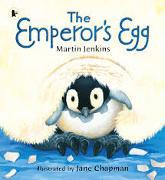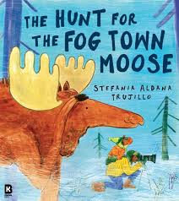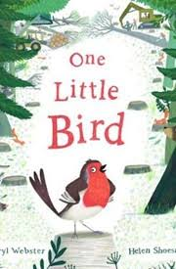


Learning Through Play This Term

Here are just some of the exciting activities we have planned:
- Ice melting experiments
- Frozen treasure hunts
- Winter small‑world play
- Arctic animal role‑play
- Snowflake art and printing
- Exploring light and shadow
- Outdoor winter walks
- Sensory trays with ice, snow, and cool colours

As always, we will also be encouraging lots of language development through storytelling, new vocabulary, and imaginative play.

How You Can Support at Home
- Talk about the weather and seasonal changes
- Read winter‑themed stories together
- Encourage children to notice frost, ice, or winter birds
- Practise putting on coats, hats, scarves, and gloves independently
- Share any winter photos or experiences with us on class dojo—we love seeing them!

A couple of bits of housekeeping…We are welcoming several new children at the start of this term which means our little cloakroom starts to get even busier! To that end, once we have navigated the normal wobbles of the first week or so back this term, please can parents leave children at the preschool gate as much as possible. As always, I will be waiting to welcome everyone in with Miss Jones, Miss Richardson and Miss Moody ready to support. If your child does become a little upset, the team and I are there to comfort them and on the whole they become fairly settled very quickly. For new families, it is our usual practice in this situation, to message parents via class dojo once a child has calmed down to give a little peace of mind.

Whilst September may seem a long way off, the transition process of moving into reception class for our 2026 cohort (the preschoolers) starts now behind the scenes quietly and discreetly, building up as we head towards July. Ensuring the preschooler children come into school with increasing independence and confidence is an integral part of a smooth and happy transition for them into reception class.

Lastly please remember to pack your child an afternoon snack and drink, every day. Also please ensure they have indoor shoes/slippers, hats, gloves and thick coats, we venture out regardless of the weather and want everyone to be comfy and warm.

If you have any concerns or questions, please get in touch.

Kind Regards

Mrs C Gay

Claire.gay@northluffenham.rutland.sch.uk

Church Street, North Luffenham, Nr. Oakham, Rutland. LE15 8JR
Telephone: 01780 720184 • Email: office@northluffenham.rutland.sch.uk • Website: www.northluffenham.org
Let your light shine _{Matthew 5:16}










