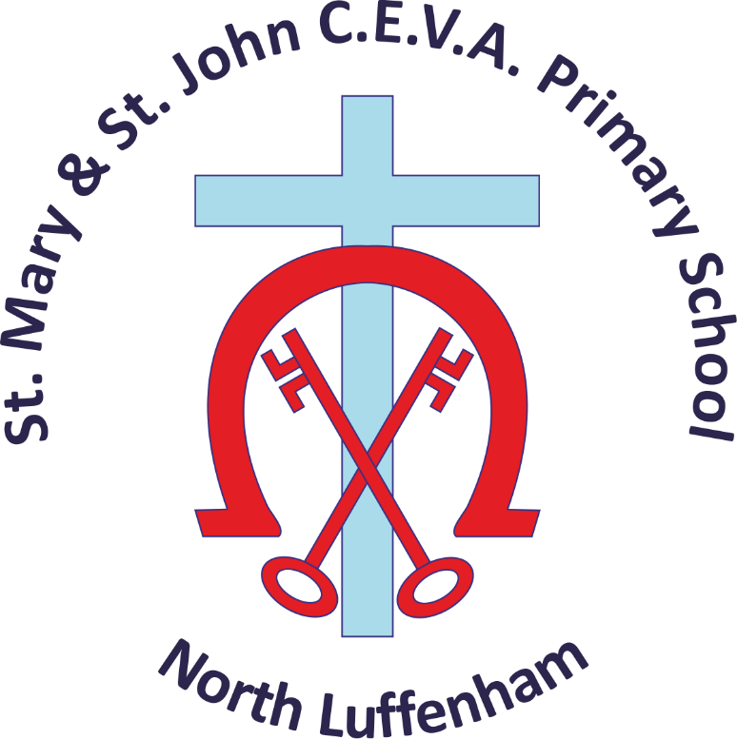
Collective Worship Policy

Let your light shine _{Matthew 5:16}

Record of Changes
Christian Values Committee
Review July 2025 | Updated timings

At St Mary & St John Church of England VA Primary School we understand worship to be a special act or occasion whose purpose is to show reverence to God. Collective worship involves pupils and staff coming together and participating in a daily gathering. In line with the 1988 Education Reform Act which states that collective worship should be wholly or broadly of a Christian character, we base our collective worship on the teachings of Christ and traditions of the Christian Church. However, we aim to conduct our collective worship in a manner that is sensitive to the individual faith and beliefs of all members of school.
Collective worship is an integral part of our day. It contributes significantly to the ethos of St Mary & St John Church of England VA Primary School. It is our aim that it is a time when the school community can:
- Share common aims and values
- Celebrate achievement and special times
- Explore together the world in which we live
- Develop a community spirit

Aims and purpose of Collective Worship are:
- To provide an opportunity for our children and school community to worship God
- To enable our children and school community to consider spiritual and moral issues
- To enable our children and adults to explore their own beliefs and develop spiritually
- To encourage participation and response
- To develop in children a sense of community spirit
- To promote a common ethos with shared values and to reinforce positive attitudes
- To introduce different ways of worshipping

At St Mary & St John Church of England VA Primary School collective worship is the heartbeat of our school and as thus has a special place in our life and work as we offer the distinctive contribution of a Voluntary Aided Church School. We provide an opportunity for children and staff to worship in a traditional Christian style, which is consistent with the traditional beliefs and practices of the Church of England. Our worship aims to be Inclusive, Inspirational and Invitational.
"Inspirational collective worship should lead pupils to become courageous advocates of causes and encourage them to think searchingly about their faith, beliefs and/or philosophical convictions."
Practicalities of Organisation
We hold a daily act of collective worship either in our church, St John the Baptist or the school. The format for these is agreed annually and an example is in the appendix.
We conduct collective worship in a dignified and respectful way. We tell children that worship time is special thinking time for calm reflection. We regard it as a special time and expect them to behave in an appropriate way. We ask them to be quiet and thoughtful and to listen carefully to the teaching and invite them to participate in prayer and songs. We create an appropriate atmosphere by using music and a candle that acts as a focal point for the attention of the children.
The Headteaccher, Key Stage Leaders and other members of staff conduct collective worship but usually on Mondays our parish priest – The Rector or the Assistant Vicar from the Rutland Water Benefice and/or Headteacher leads. This brings greater variety to our worship times and strengthens links between school and the local church.
Parents are invited on a Friday afternoon to celebration worship and other special services e.g. Christmas, Easter and the end of the school year. This promotes the community spirit of the school. We welcome governors’ attendance at our collective worship at any time. Other opportunities for prayer and reflection are given at lunchtimes and in classes at the end of each school day. Worship opportunities are also offered to staff, children and their families as we attend services (eg Christingle and end of year services in St John the Baptist church, North Luffenham, St Mary’s church, South Luffenham and St Peter’s in Barrowden.
Content
We aim for collective worship to be engaging, inspiring and transformational. Content often reflects on values and particularly those we have chosen as shaping our school’s Christian vision and ethos, as well as considering and reflecting on the festivals and special times of the Christian calendar. Our school values are Compassion, Resilience and Respect. We also hold collective worship that reflects on and celebrates children’s (and staff) achievements and learning, as everyone is valued and all achievements recognised. This also provides an opportunity for children to participate in collective worship by showing their work to others and sharing issues that they have discussed in their classes. This plays an important part and supports the promotion of the deeply Christian ethos of the school.
Collective Worship is planned across the year and a record is kept of all acts of worship, recording themes covered and songs/music used.
Our Y6 Wildfire crew support worship by creating our Friday prayer for Celebration worship (from suggestions in our prayer box), reading in worship and leading reflections on worship in classrooms.
Evaluation, Monitoring and review
It is the role of a the CW link governor and Christian Values (and Admissions) committee to monitor the policy and practice of collective worship. As part of this, pupil interviews are carried out and pupil evaluation forms are reviewed etc. The link governor liaises with the headteacher before reporting to governors on collective worship.
Right of Withdrawal
We expect all children to attend collective worship, and we discuss this with parents at the time of admission. However, any parent can request permission for their child to be excused from attending religious worship and the school will make alternative arrangements for the supervision of the child during the period concerned. Parents do not have to explain or give reasons for this. This complies with current legislation. The Head Teacher keeps a record of any children who are withdrawn from Collective Worship.

Appendix A

 | Collective Worship Timetable
Monday | Whole School Church Service | 9.00am - 9.20am
Tuesday | Whole School | 3pm – 3.20pm
Wednesday | Whole School | 3 pm – 3.20pm
Thursday | House worship, Key stage worship or Picture news in class worship | 1.10pm – 1.30pm
Friday | Parents & Celebration Worship | 3 pm – 3:25pm

